Iowa Holstein Auxiliary Scholarship 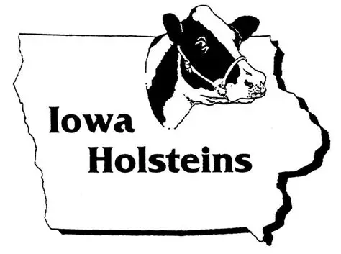
The Iowa Holstein Auxiliary awards scholarships every year to deserving students. Applicant must be a member of the Iowa Junior Holstein Association at the time of application. Applicant must be a high school graduate and currently attending either a four-year college, or a one or two-year tech school or a short course program and NO association with dairy science as either a major or minor. Previous scholarship winners are not eligible. Please send your completed application to: Kathy Demmer, 6222 Sundown Rd, Peosta, IA 52068 or by email at rkleola@yousq.net. The deadline is February 1.

Iowa Holstein Auxiliary Scholarship Application

Name:
Address:
Phone:
School Address if applicable:
Email:
Age (DOB):
Parents' Names:
1. School: - Name of High School or College and current program of study - Present grade or year – expected year of college graduation - GPA and/or class standing/number in class (If a college freshman, include H.S. GPA)

2. List Holstein Association leadership and involvement, including county, district, state and national activities

3. List other leadership roles

4. List student, community and organization activities

5. Answer each of the following questions in 200 words or less per
question. (Please type)

A) How did you get involved in the Iowa Junior Holstein
Association?

B) What skills have you developed that you learned as a
member of the Iowa Junior Holstein Association and how are
they benefitting you today?

C) What are your future plans and how will you use skills learned
from your Holstein background or Junior Holstein activities to
achieve your goals?

6. Who has made an influence and why, in your life and future goals?

